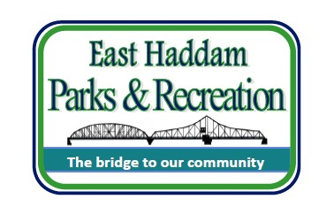

Minimum Qualifications:
- Must be 16 years of age

East Haddam Parks & Recreation
1 Plains Road
P.O. Box 385
East Haddam, CT 06423 Phone: 860-873-5058
Email: parkandrec@easthaddam.org Website: www.easthaddamrec.com

LEARNING LAB COUNSELOR JOB DESCRIPTION

- Previous camp or child care experience preferred
- Desire and ability to work with children in a learning setting
- Ability to accept supervision and guidance
- Ability to assist in online learning requirements of each child as well ability to assist in teaching an activity
- Enthusiasm, sense of humor, and patience
- Ideal candidates will be college students (education majors a plus)

Job Description: To provide general guidance, support, and leadership to an assigned group of young learners under the direction of the Recreation Director.

Typical Responsibilities and Duties: The following list is not a complete list, but reflects typical responsibilities and duties. Counselors are expected to perform all duties as requested:
- Uphold all policies, philosophies, and safety guidelines of East Haddam Parks and Recreation
- Supervise and assist participant with their distance learning program
- Assist all staff in carrying out activities planned in their specific area and supervising young learners
- Be responsible for the welfare of each individual in assigned section and do everything possible to pro- actively solve problems
- Work with young learners to foster a respect for East Haddam Park and Recreation property and instill a civic duty to keep the learning lab facilities clean
- Assist campers with organization and proper storage of personal items to prevent loss
- Participate in all learning lab activities and events
- Assist in brainstorming and organizing activities for learners during breaks from online classroom learning
- Some duties may be reassigned and other duties may be assigned as required

Essential Functions:
- Ability to communicate with staff, parents, and children as well as provide necessary instruction to participants
- Visual and auditory ability to identify and respond to environmental and other hazards
- Counselors are role models for young learners - be a great one that they will remember.

Reviewed 8/2020

